

**END OF TERM ONE EXAMINATIONS 2023**

**MIDDLE CLASS**

**MATHEMATICAL CONCEPTS**

NAME_______________________________

1. **Copy and write**.

|  |  |  |  |  |  |  |  |  |  |  |  |  |  |  |  |
| --- | --- | --- | --- | --- | --- | --- | --- | --- | --- | --- | --- | --- | --- | --- | --- |
| 0 | 1 | 2 | 3 | 4 | 5 | 6 | 7 | 8 | 9 | 10 | 11 | 12 | 13 | 14 | 15 |
|  |  |  |  |  |  |  |  |  |  |  |  |  |  |  |  |
|  |  |  |  |  |  |  |  |  |  |  |  |  |  |  |  |

1. **Count and write**.

= ___________

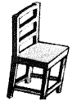

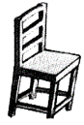

= ___________

= ___________

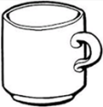

= ___________

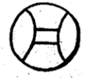

= ___________





= ___________

1. **Ring the same numbers**.

11 11 12

15 10 15

3 4 4

7 8 7

9 9 2

1. **Colour for the number**.

10 =

1 =

9 =

5 =

6 =

1. **Circle the correct number**.

4

4

4

3

3

3

7

7

7

5

5

5

1. **Write the correct number**.

9

3

4

2

7

5

6

01

1. **Match and write**.

11 1

12 6

13 8

14 5

15 14

10 2

9 7

8 12

6 11

1 13

2 9

7 15

5 10